A crime has taken place and the detective needs your help. The detective gave you the crime scene report, but you somehow lost it. You vaguely remember that the crime was a **​murder​** that occurred sometime on ​**Jan.15, 2018​** and that it took place in ​**SQL City​**. Start by retrieving the corresponding crime scene report from the police department’s database.

Select *

from crime_scene_report

where crime_scene_report.date = 20180115 AND crime_scene_report.type = 'murder' And city = 'SQL City'

**First Witness**

Select Name, address_number

From person

Where address_street_name Like 'Northwestern Dr'

Order By address_number

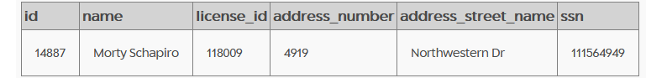

Select *

From interview

where person_id = 14887

**Second Witness**

Select *

from person

where address_street_name ='Franklin Ave' and name like 'Annabel%';

Select *

from interview

where person_id = 16371

**Evidence Gathered from Witness Claims**

Select *

from drivers_license

where plate_number Like '%H42W%'



Select *

from get_fit_now_member

where id Like '%48Z%'



**Gym Logs**

Select *

from get_fit_now_check_in

join get_fit_now_member on get_fit_now_member.id = get_fit_now_check_in.membership_id

where check_in_date = 20180109 and get_fit_now_member.id like '%48Z%'

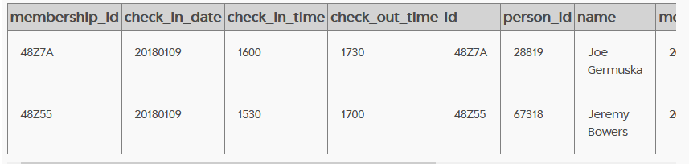

**Comparing Names to driver’s license**

Select license_id,name

from person

where name = 'Joe Germuska' or name = 'Jeremy Bowers'

Select *

from drivers_license

where id = '173289' or id = '423327'

Chevy Spark matches Annabel’s claims and he was checking into the gym the night she said she recognized him. He is also a gold member at the gym with an ID that matches what Monty supplied.

**Suspect Information**

select *

from person

where license_id = '423327'

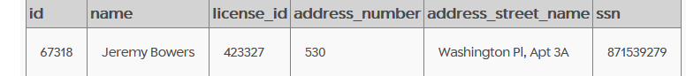

**Suspect Interview**

select *

from interview

where person_id = '67318'

**Woman Who Hired**

select *

from drivers_license

where car_make = 'Tesla'and height Between 65 and 67



Select *

from person

where license_id = 202298 or license_id = 291182 or license_id = 918773

**Checking Events**

Select *, count(*)

from facebook_event_checkin

where event_name like '%SQL Symphony%' and person_id = "99716"

Miranda Priestly matches the suspect’s interview.

**Checking the Solution**

INSERT INTO solution VALUES (1, 'Miranda Priestly');

SELECT value FROM solution;

